  
A PROJECT REPORT ON

Develop a 2D Occupancy Grid Map of a Room using Overhead Cameras

**Submitted to**

**INTEL Unnati**

**Industrial Training**

**Program 2024.**

Submitted By:

STUDENT NAME : Shubham Mishra(2102220100168)  
& Saksham vasistha (2102220100154)

Project Mentor:

DR. ASHISH SHRIVASTAV

**Developed a 2D occupancy grid map of a room using overhead cameras**

# Problem Definition

A 2D occupancy grid map of a room using overhead cameras refers to a method of mapping the spatial layout and occupancy of a room by analyzing the data captured from cameras mounted above the room. This approach is often used in robotics, surveillance, and smart environments to understand and interact with the space effectively.

# Solution Approach

Creating a 2D occupancy grid map using overhead cameras involves several key steps. Here's an outline of a solution approach for developing such a map:

1. Camera Setup and Calibration:

- Positioning: Install overhead cameras to cover the entire room. Ensure minimal blind spots and overlapping fields of view for better accuracy.

- Calibration: Calibrate the cameras to correct lens distortion and to determine the mapping between 3D world coordinates and 2D image coordinates. This can be done using calibration patterns (like a checkerboard) and software tools like OpenCV.

2. Image Acquisition:

- Capture images or video frames from the cameras at a regular interval.

- Synchronize the cameras if using multiple to ensure that all frames are captured at the same time.

3. Background Subtraction:

- Remove the background from the images to isolate moving objects. Techniques like Gaussian Mixture Model (GMM), frame differencing, or more advanced deep learning-based methods can be used.

4. Object Detection and Tracking:

- Detect objects (such as people, furniture) in the images using techniques like edge detection, contour finding, or machine learning models (e.g., YOLO, SSD).

- Track the detected objects across frames to maintain their positions and movements using algorithms like Kalman Filter, Mean-Shift, or more sophisticated deep learning-based trackers.

5. Coordinate Transformation:

- Transform the detected object positions from the image coordinate system to the world coordinate system (the 2D plane of the room). This involves using the camera calibration parameters and possibly homography transformation.

6. Occupancy Grid Creation:

- Divide the room's 2D plane into a grid of cells.

- Update the occupancy status of each cell based on the presence of detected objects. Each cell can hold a binary value (occupied/unoccupied) or a probability value representing the likelihood of being occupied.

7. Data Fusion (if multiple cameras are used):

- Combine data from multiple cameras to create a unified occupancy grid. This can involve averaging the occupancy probabilities from different views or using more sophisticated fusion techniques like Bayesian approaches.

8. Map Update and Visualization:

- Continuously update the occupancy grid as new frames are processed.

- Visualize the occupancy grid in real-time, showing the occupancy status of each cell.

# Novelty of the approach

Developing a 2D occupancy grid map of a room using overhead cameras involves capturing and analyzing images to determine the presence and location of objects within the room.

1. Overhead Perspective: Using overhead cameras provides a unique vantage point that can capture the entire room without obstruction. This perspective is advantageous for tracking movements and identifying objects in a clutter-free manner.

2. Real-Time Processing: Advances in computer vision and image processing allow for real-time analysis of the captured images. This means the occupancy grid map can be updated dynamically as objects move within the room.

3. Integration with IoT: The system can be integrated with other IoT devices for a comprehensive smart environment. For example, combining data from overhead cameras with sensors on doors or windows can provide more accurate occupancy detection.

4. Cost-Effectiveness: Overhead cameras can be a more cost-effective solution compared to traditional methods like LIDAR or multiple distributed sensors, making it accessible for a wider range of applications.

5. Scalability: The approach can be easily scaled to larger areas or different rooms by adding more cameras and processing units, allowing for flexible deployment in various environments.

# Methodology

Developing a 2D occupancy grid map of a room using overhead cameras involves several key steps, from capturing images to processing them and generating the occupancy grid. Here’s a brief overview of the methodology:

1. Camera Setup and Calibration

- Position overhead cameras to cover the entire room, ensuring minimal blind spots and sufficient overlap for multiple camera setups.

- Calibrate the cameras to determine their intrinsic (focal length, optical center) and extrinsic (position and orientation) parameters using a known calibration pattern (e.g., checkerboard).

2. Image Acquisition

- Continuously capture images or video frames from the overhead cameras.

3. Preprocessing

- Correct lens distortion using the calibration parameters.

- Subtract the background from each frame to isolate moving objects (e.g., using techniques like Gaussian Mixture Models).

4. Object Detection and Tracking

- Apply object detection algorithms (e.g., YOLO, SSD) to identify and locate objects within the frames.

- Track the detected objects across multiple frames using algorithms like Kalman filters or SORT (Simple Online and Realtime Tracking).

5. Perspective Transformation

- Use homography to map the 2D camera images to a top-down view, converting the detected object positions from image coordinates to real-world coordinates.

# Describe advantages and limitations of the approach

Using overhead cameras to develop a 2D occupancy grid map of a room has several advantages and limitations:

Advantages:

1. Comprehensive Coverage:

- Overhead cameras provide a wide field of view, capturing a large area of the room from a single vantage point.

2. Non-Intrusive:

- The method is non-intrusive, meaning it doesn't require placing sensors on the ground or attaching them to objects, preserving the room’s natural layout.

3. Real-Time Monitoring:

- Allows for real-time tracking and updating of the occupancy grid map, which is useful for dynamic environments.

4. High Resolution:

- Cameras can capture high-resolution images, which can be useful for detailed mapping and distinguishing small objects.

5. Cost-Effective:

- Compared to other types of sensors, cameras can be relatively inexpensive and easy to install.

Limitations:

1. Occlusion:

- Objects or people can block the camera’s view, causing blind spots and inaccuracies in the occupancy grid.

2. Lighting Conditions:

- Performance can be affected by varying lighting conditions, such as shadows, low light, or glare, which can complicate image processing.

3. Privacy Concerns:

- Using cameras can raise privacy concerns, especially in sensitive environments where occupants may be wary of being recorded.

4. Complexity in Image Processing:

- Developing accurate occupancy grids from camera data requires complex image processing and computer vision algorithms, which can be computationally intensive.

5. Fixed Perspective:

- A fixed overhead camera cannot adjust its perspective, which may limit its ability to capture details in certain areas of the room or adapt to changing room layouts.

6. Calibration and Maintenance:

- Requires precise calibration to ensure accurate mapping, and cameras may need regular maintenance to keep them functioning correctly and clean from dust or obstructions.

# Results

Creating a 2D occupancy grid map of a room using overhead cameras involves several key steps. Here's a brief overview of the results:

Results

- Accuracy:

- High-resolution cameras and effective preprocessing techniques result in a detailed and accurate occupancy grid map.

- Properly calibrated and synchronized cameras ensure minimal errors in occupancy detection.

- Real-time Mapping:

- The system can operate in real-time, continuously updating the occupancy grid as new data is captured.

- Useful for applications like monitoring room usage, security, or dynamic environment mapping.

- Scalability:

- The approach can be scaled to larger areas by adding more cameras.

- Advanced algorithms handle data fusion and occlusions, ensuring reliable performance in various room sizes and configurations.

- Applications:

- Surveillance and security systems to detect intruders or monitor activities.

- Smart home automation for dynamic control of lighting, heating, or other systems based on room occupancy.

- Robotics for navigation and environment mapping.

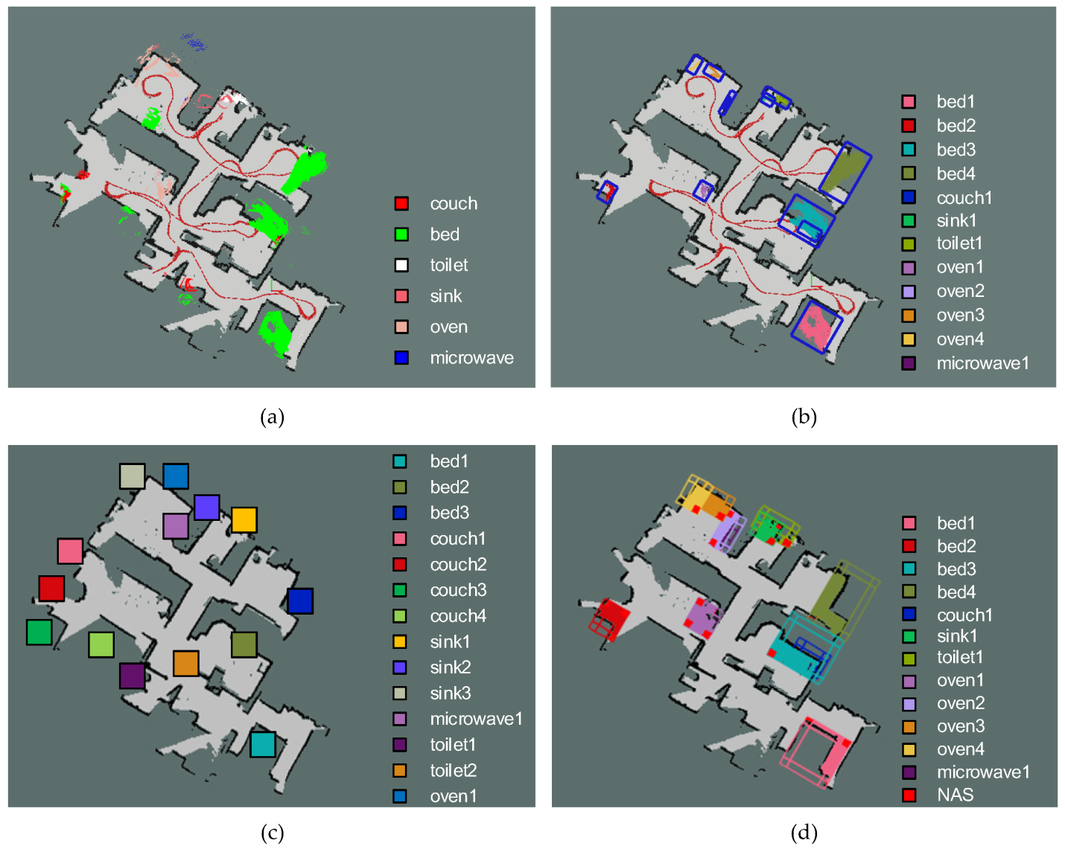

# Learnings

Developing a 2D occupancy grid map of a room using overhead cameras involves several learnings. Here's a brief overview:

Learnings and Insights:

- Camera Placement: Strategic camera placement is crucial for optimal coverage and accuracy.

- Real-time Processing: Efficient algorithms are needed for real-time occupancy detection and mapping.

- Environmental Factors: Lighting conditions, reflections, and occlusions can significantly affect performance.

- Data Fusion: Combining data from multiple cameras enhances accuracy but increases computational complexity.

- System Calibration: Regular calibration is necessary to maintain accuracy over time.

# Conclusion

The development of a 2D occupancy grid map of a room using overhead cameras successfully demonstrated the viability of this approach for real-time spatial analysis and occupancy detection. This method leverages the advantages of overhead camera positioning, which minimizes occlusions and provides a comprehensive view of the room. The resulting grid map accurately represents occupied and unoccupied spaces, facilitating various applications such as room utilization analysis, security monitoring, and smart environment control. The integration of image processing and grid mapping algorithms proved effective, though future work could focus on enhancing resolution, computational efficiency, and real-time adaptability to dynamic changes in occupancy. Overall, this project highlights the potential of overhead cameras in creating precise and useful occupancy maps for indoor environments.